Cloud Infrastructure 2

Introduction
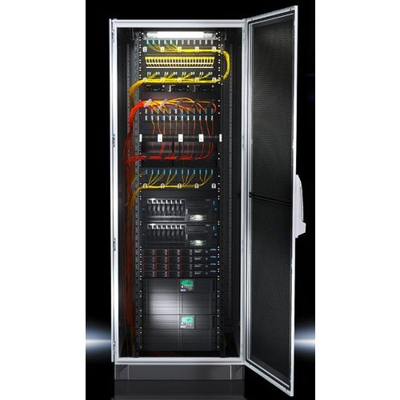
The main goal of the course Cloud Infrastructure 2 is to prepare students to work in a server environment, to know the specifics of server hardware and to be able to build cloud infrastructure from scratch.

The official learning outcomes of the course are:
- explain the purpose and function of server form factors
- compare and contrast power and cooling components
- describe the current market situation on server hardware
- compare and determine the benefits of dedicated server hardware versus IAAS from public cloud providers
- plan and configure a customized rack for a given scenario

Course Content
In groups of 2, you will be handed a real 19” server. The goal is to get this server to work, to be able to start an operating system and to turn the server into a fully functioning network attached storage (NAS).
After the installation, it should be installed into a 19” server rack and be connected to the network. Finally, you should be able to upload/download data to/from your server using dedicated shared folders on the server’s hard disks.
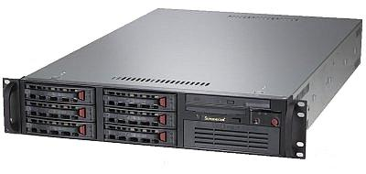





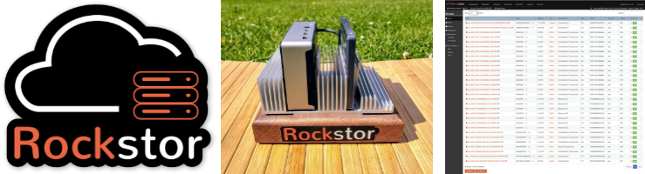


Requirements
The project is split into the following parts and activities:
- Information
  - Do some research about the topic NAS. What is it? What is it used for?
  - What it the difference between DAS, NAS and a SAN?
  - Explain why in a professional environment, compute (CPU/RAM) and storage are usually separated.
  - Describe the server form factor and casing dimensions
  - Describe all the external server ports and connectors
  - Open the casing and describe all the internal hardware components
  - Describe all internal ports and connectors
- Staging (Server hardware and firmware preparation)
  - Install the RAM modules
  - Install the native HDDs
  - Install the RAID controller and the RAID HDDs
  - Check the power supplies for correct function and simulate a failure
  - Connect a monitor, a keyboard and a mouse to the server
  - Check the hardware in the BIOS (Has everything been detected correctly? Any error codes or messages?)
  - Check the BIOS configuration (RMM IP address, boot media, ...)
  - Check the RAID controller IP configuration
- RAID controller configuration
  - Connect the RAID controller network port and open the RAID controller web interface
  - Create a new RAID 5 array consisting of the 3 SAS disks naming the volume areca_raid5.
- OS installation
  - Describe your NAS software.
    - What is it?
    - Who created it?
    - Which is the latest release?
    - How much does it cost?
    - What are the most important features?
    - Why should or shouldn’t you use it?
  - Create a separate USB installation medium
  - Plug in the installation USB medium in the front of the server and boot from it.
  - Install the NAS operating system onto the rear connected empty USB stick (except for Rockstor which needs to be installed on an internal SSD).
  - After the installation, remove the installation medium from the front USB port, start your NAS OS from the rear USB stick and perform the main configuration
    - Username/Password
    - Network configuration
    - Hostname

- Installation
  - Plan the rack installation and coordinate with other teams on timing and spacing
  - Install both rails horizontally in the rack (pay attention to install them correctly!)
  - Place the server on rails and make sure that the rails snap in place so the server is mounted tightly.
  - Connect the power and network cables ( 1x LAN to the RAID controller, 1x LAN to the Mainboard, 1x LAN to the RMM connector)
  - Connect to the server using the Remote Management Module (RMM)
- NAS configuration and testing
  - In the NAS interface, you should find the areca_raid5 volume which is already redundant due to the RAID controller.
  - Create another RAID 1 volume in the NAS OS using the 2 SATA disks in the server calling it software_raid1. At the end you should have 2 RAID volumed:
    - RAID 5 “areca_raid5” using the Areca hardware RAID controller
    - RAID 1 “software_raid1” using your NAS OS software RAID feature
  - Create a file sharing system using the two RAID arrays and propose a shared folder structure, user permissions, and network protocols for the following scenario. A family wants to use your server as a central home storage for their data like pictures, video, document and also backups. Many users should have mixed access rights and they use a variety of client devices to access the shared folders (Windows, Linux, Mac). It’s up to you to check out the potential of your NAS OS and and make a realistic proposition on how to best solve this problem.
  - Try connecting to those shared folders using your computer as a client. Upload and download data to test if it works fine. Try out different user permission settings.
  - Do research on the iSCSI protocol. What is the difference to NFS or SMB? Check if iSCSI is supported by your NAS OS and test iSCSI.

You will need your NAS later in the VIRCL course, so make sure to install and configure it properly and test all the features thoroughly.

Hardware Equipment
At the end of the project, every server shall be equipped with the following hardware:
- RAM: 8x2GB
- Native HDDs
  - 1x 160GB SATA in slot “DRIVE_0” connected to SATA_0 on Mainboard
  - 1x 160GB SATA in slot “DRIVE_1” connected to SATA_1 on Mainboard
- RAID controller installed in PCI Express Slot with backup battery attached.
- RAID HDDs
  - 3x Seagate SAS Cheetah 146GB in slots “DRIVE_2-4” connected to ports 1-3 of RAID controller
- 2x working power supplies
- 1 Samsung USB stick connected to a rear USB port for the OS

NAS software
There are many different free and commercial solutions to turn any server into a storage server. Here’s a list with some examples:
- XigmaNAS
- OpenMediaVault
- Rockstor (needs to be installed in internal HDD/SSD, not working on USB)
- TrueNAS Core (FreeBSD)
- TrueNAS Scale (Debian)
- UnRAID (commercial)
To install the OS, you must do some individual research. At the end the chosen OS must be installed on the external rear Samsung USB stick. All the HDDs must be used for storage purposes only (except Rockstor -> installed on SSD)

Deliverables and Evaluation
For the evaluation of this project, you must deliver 3 parts each graded for 20 points.
- Correctly installed storage server in the mobile rack. (10P)
- Documentation of all the requirements mentioned above including pictures and technical details. Must be handed in as an official report containing title page, TOC&TOF, used sources and personal conclusion. (20P)
- Presentation of 20 minutes and live demonstration of your NAS solution. The presentation should be focussed on demonstrating the functions and specialities of your NAS software. Presentations need to be held even if 1 group member is absent, so be prepared! (30P)

Teams and Deadlines
The practical part ends on 18.03.2026. On this day, the servers must be installed, and every team must upload their documentation to eduMoodle. The slideshows must be uploaded to eduMoodle prior to the presentation on the 13.04.2026.

Team | Members | NAS OS | Server
1 |  | XigmaNAS
2 | Marios, Christophe | OpenMediaVault | MR3S01
3 | Yona, Donny | Rockstor | MR3S02
4 |  | TrueNAS Core
5 | Max, Sven, Eric | TrueNAS Scale | MR3S03
6 | Andrea, Gui | UnRAID (commercial) | MR3S04

Information table
Server Name | HDD | RAM | USB Sticks | Server LAN1 IP | Server LAN1 hostname | ILO/RMM IP | RAID IP
MR3S01 | 2x 160GB SATA + 3x SAS | 8x2GB | 1x Samsung + 1x Sandisk | 10.0.13.1 | MR3S01 | 192.168.0.39 | 192.168.0.139
MR3S02 | 2x 160GB SATA + 3x SAS | 8x2GB | 1x Samsung + 1x Sandisk | 10.0.13.2 | MR3S02 | 192.168.0.40 | 192.168.0.140
MR3S03 | 2x 160GB SATA + 3x SAS | 8x2GB | 1x Samsung + 1x Sandisk | 10.0.13.3 | MR3S03 | 192.168.0.41 | 192.168.0.141
MR3S04 | 2x 160GB SATA + 3x SAS | 8x2GB | 1x Samsung + 1x Sandisk | 10.0.13.4 | MR3S04 | 192.168.0.42 | 192.168.0.142
MR3S05 | 2x 160GB SATA + 3x SAS | 8x2GB | 1x Samsung + 1x Sandisk | 10.0.13.5 | MR3S05 | 192.168.0.43 | 192.168.0.143
MR3S06 | 2x 160GB SATA + 3x SAS | 8x2GB | 1x Samsung + 1x Sandisk | 10.0.13.6 | MR3S06 | 192.168.0.44 | 192.168.0.144
MR3S07 | 2x 160GB SATA + 3x SAS | 8x2GB | 1x Samsung + 1x Sandisk | 10.0.13.7 | MR3S07 | 192.168.0.45 | 192.168.0.145

General information for RMM and RAID interface only!
- Subnet mask 255.255.255.0
- Gateway 192.168.0.254
- DNS: 8.8.8.8

General information for LAN interface only!
- Network: 10.0.0.0/16
- Subnet mask: 255.255.0.0
- Gateway: 10.0.0.1
- DNS: 10.0.0.1

